Arctic King 7.0CF Upright Freezer, White - ARU07M2AWW -

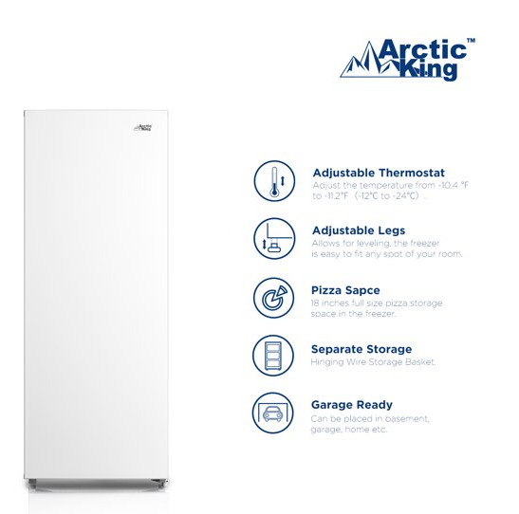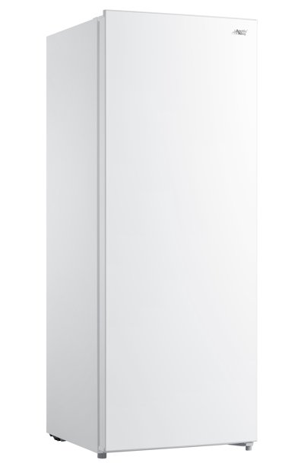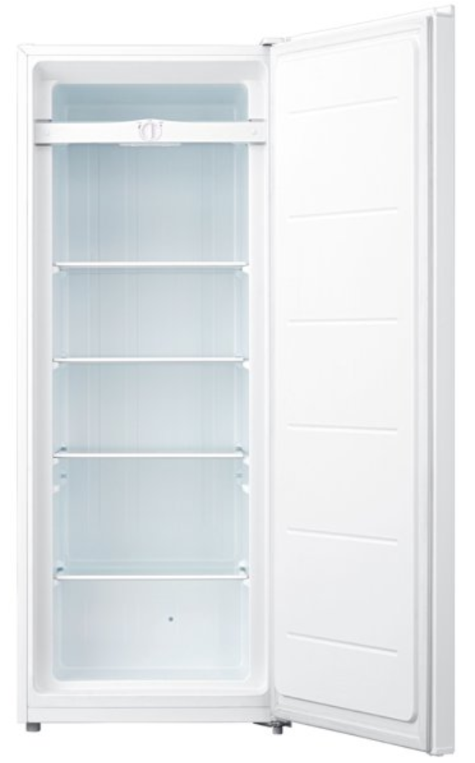
he Arctic King 7.0CF Upright Freezer, White has the ideal amount of space for stocking up on your favorite frozen foods whether you're having a big family gathering or simply want to store for the future. The Arctic King Upright Freezer can be used at home in offices, mudrooms, garages and basements where it provides supplemental freezer space. The skinny size and recessed handle of the Arctic King Upright Freezer makes it an excellent fit in another storage space in your house for easy access. Includes a mechanical temperature control so you can change it higher or lower with an adjustable thermostat. The Arctic King Upright Freezer has an easy-to-clean interior for added convenience. The drain plug allows for easy cleaning and manual defrosting. Offering a wide range of temperatures, the goodness of your favorite foods is locked in for longer. With an interior that's easy to clean, the freezer door opens at increments from 45-75 degrees so you can easily pack and unpack your favorite foods. The Arctic King Upright Freezer features a balanced hinge design, so you can ensure that you can get in and out of it with ease. You will have top quality construction and proper storage with the Arctic King 7.0CF Upright Freezer, White. Arctic King 7.0CF Upright Freezer, White:
- Easy to get temperature you like with adjustable thermostat
- Best experience with uniform cooling and fast Freeze
- Unique design for Pizza storage
- It's Garage Ready
- Easy organization with adjustable glass shelves
- Reversible door hinge for right and left opening
- Adjust to keep your upright steady with adjustable legs
- Model# ARU07M2AWW

